OPERATING SYSTEMS AND SYSTEMS PROGRAMMING

2520030371 – P. HAVISHAA REDDY

SKILL 1:

Step 1: Open PowerShell as Administrator
- Press Windows.
- Search for PowerShell.
- 3. Right-click Windows PowerShell.

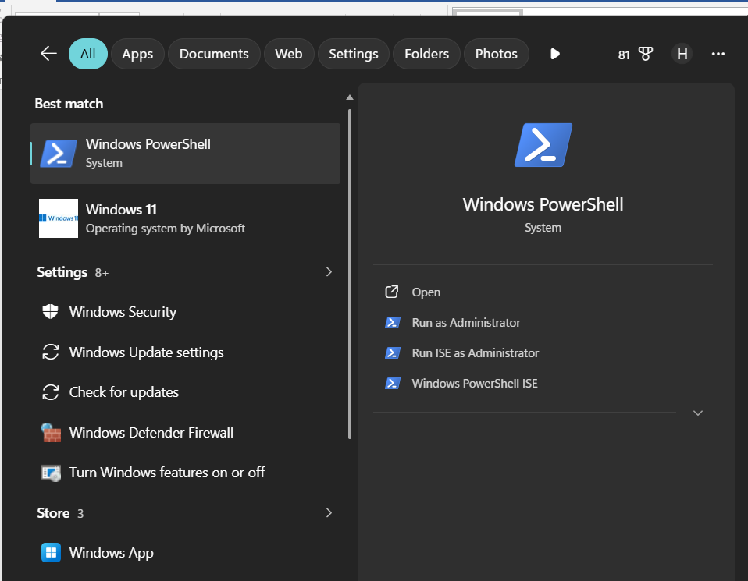

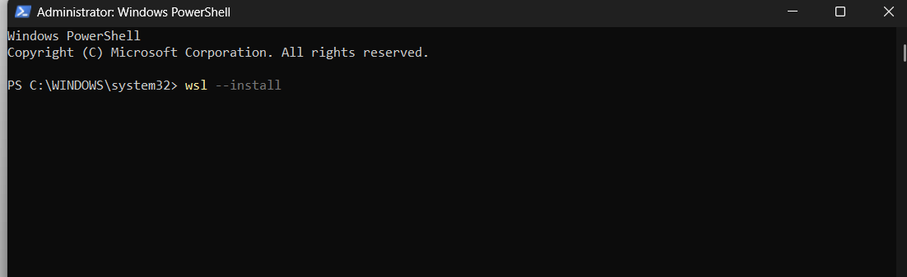

Update Ubuntu:
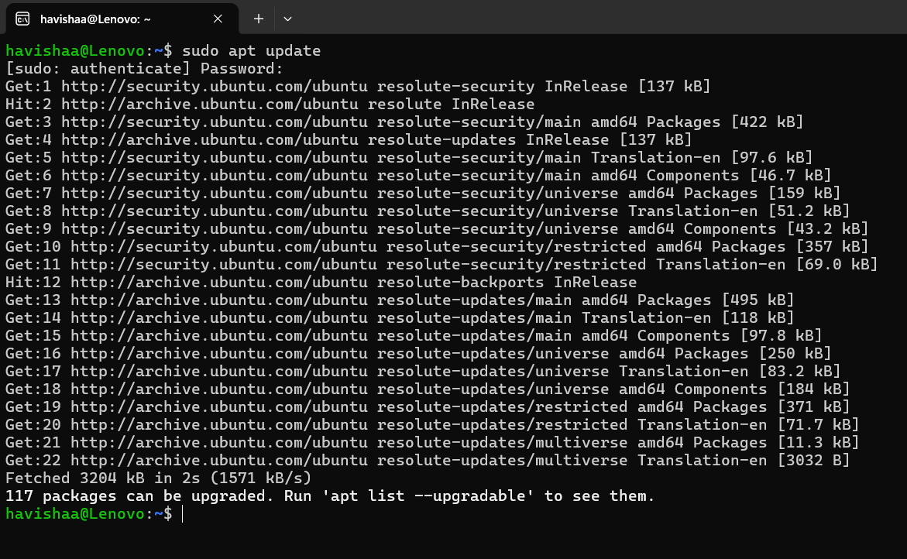

Install GCC (C Compiler):
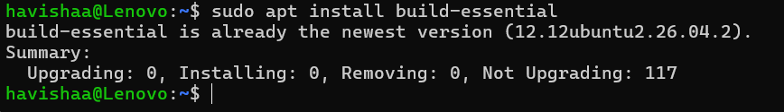

Verify the Installation:
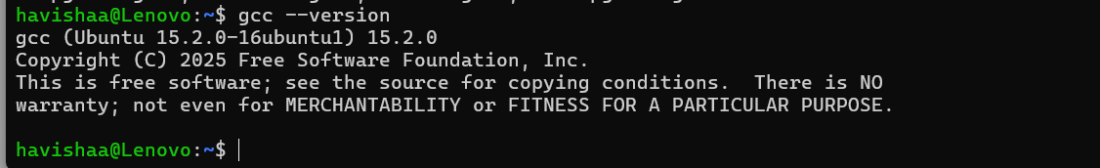

Write and compile a C-program:
